**DATABASE MANAGEMENT SYSTEMS 1 - ASSIGNMENT 3**

**Mukatova Aruzhan, 17-p**

**Zharylkapova Anel, 17-p**

**Slambek Dina, 18-p**

**Iskendirov Almas, 12-p**

**TASK 1 (5 points)**

**Pick up a real-world structure that needs a database and create a short user story on it.**

TV channel database stores :

The main object that we are considering is ‘TV channel’ which has attributes like ‘name’, ‘chanId’, ‘Digital TV family’, ‘Image formatting’, etc. Each TV channel **has** its own content (‘Cartoons’, ‘Movies’, ‘Shows’, ‘News’, and so on) and **divides into** different departments(Management, Office, and Production). The department that **manages** the whole system includes the CEO, the owner. The office department consists of an accountant, PR manager, lawyer, journalist. The filming process is the duty of the production team(director, writer, cameraman, etc). In addition to that, the employee(employee id, full name, post) of the TV channel **receives** some benefit(‘Salary’, ‘Bonus’, ‘Leave’), and may **go on** a business trip(‘Main purpose’, ‘City’, ‘Housing’). The income of the TV channel **depends on** an **‘**Advertisement’ (on the channel or social media), ‘Ratings’, ‘Sponsoring’ (national and commercial). The expense of the TV channel **depends on** taxes, payments, rent, and so on. The ways of **reaching out** to the TV channels are calling a call center, writing by email, requesting in Headhunter. Also in order to get additional information users may check the accounts on social networks(Facebook, YouTube, Instagram, and so on).

**We have 14 objects and 116 attributes:**

**1** TV channel

1. Channel_ID (*PRIMARY KEY)
2. Name - название канала
3. Tagline - слоган
4. Digital_TV_family - цифровое телесемейство, к которому относится канал
5. TV_license
6. Service_Type (Service of delivering the television programming) - система передачи телевизионного сигнала(кабельное, спутниковое)
7. Image_formatting - формат картинки (W x H)
8. Is_active_since - дата начала вещания
9. Starting_time - время начала ежедневного вещания
10. Ending_time - время окончания ежедневного вещания
11. The_channel_voice - голос канала

**2** Employee - работник (related to Department )

1. Employee_ID (*primary key) - номер пропуска
2. Full_name
3. Gender
4. Department
5. Post
6. Office - офис/кабинет
7. Academic_degree - высшее образование
8. Length_Of_Service - стаж работы
9. Salary
10. Home_address
11. Phone_number

**3** TV_license

1. Document_number(*PRIMARY KEY)
2. Region
3. Date_receive
4. Service_life
5. Expiration_date
6. Pricing

**4** Content

1. Cartoon
2. Movie
3. TV_series
4. News
5. Sports - спортивные матчи
6. Show - шоу
7. Streaming_game
8. Music_chart
9. Stream - прямые эфиры
10. Weather
11. Advertising

**5** Department

1. Naming (*PRIMARY KEY)
2. Head
3. Main_Office
4. Functions

**6** Management

1. CEO
2. Owned_by
3. Associate_Director
4. Administrator

**7** Office Department

1. Accountant
2. PR_manager
3. Promoter
4. Journalist
5. Lawyer
6. Secretary

**8** Production

1. Director
2. Sound_producer
3. Artistic_director
4. Cameraman
5. Writer
6. Editor
7. TV_Host
8. Actor
9. Understudy
10. Sound_producer
11. Voice_actor
12. Makeup_artist
13. Stylist
14. Producer
15. Technician (ответственный за аппаратуру)

**9** Contacts

1. Email (*PRIMARY KEY) - почтовый адрес
2. Call_center
3. Postal_code - почтовый индекс
4. Fax
5. Official website - официальный сайт
6. Headhunter

**10** Social media

1. Facebook
2. Instagram
3. YouTube
4. VK
5. Twitter
6. Telegram
7. LinkedIn
8. Tiktok

**11** Incomes - доходы

1. DateInfo
2. ChanAdvert (on the channel) - реклама на канале
3. MedAdvert (on social media and website) - реклама в соц сетях и на сайте
4. Stock - акции
5. Ratings
6. Subscription
7. National_sponsoring - государственное спонсирование
8. Commercial _ponsoring - коммерческое спонсирование
9. Content_selling - продажа прав на передачи

**12** Expenses - расходы

1. DateInfo
2. Employee_benefit
3. Taxes
4. License_updating
5. Rent
6. The_upkeep - содержание офисов
7. Marketing
8. Business_trip
9. Updating_the_equipment
10. Transporting
11. Corporate_event

**13** Employee_benefit

1. Salary
2. Bonus
3. Leave
4. Sick_leave
5. Maternity_leave
6. Pension_contribution
7. Insurance

**14** Business_trip

1. The_main_purpose(*PRIMARY KEY)
2. City
3. Number_of_employees
4. Duration
5. Flight
6. Housing
7. Food

**TASK 2 (5 points)**

**Create ER-diagram for your story created in TASK 1.**

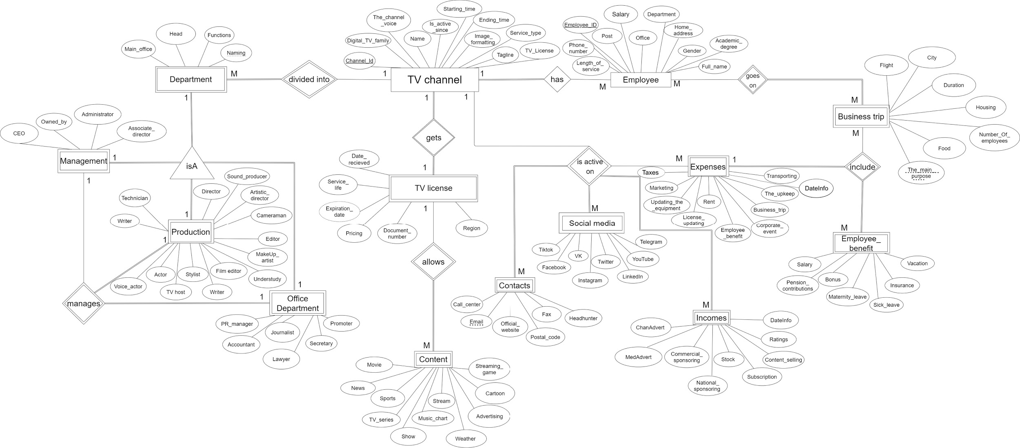

**Follow this link for better quality :**

[**https://drive.google.com/drive/folders/1-qxFDSU8-0o4t5GTDuHVjxEA9kpyyUyb**](https://drive.google.com/drive/folders/1-qxFDSU8-0o4t5GTDuHVjxEA9kpyyUyb)

**TASK 3 (20 points)**

**Create the actual database for your story on your installed software.**

1. ***Creating*** and ***inserting*** ‘TV_Channel’ table

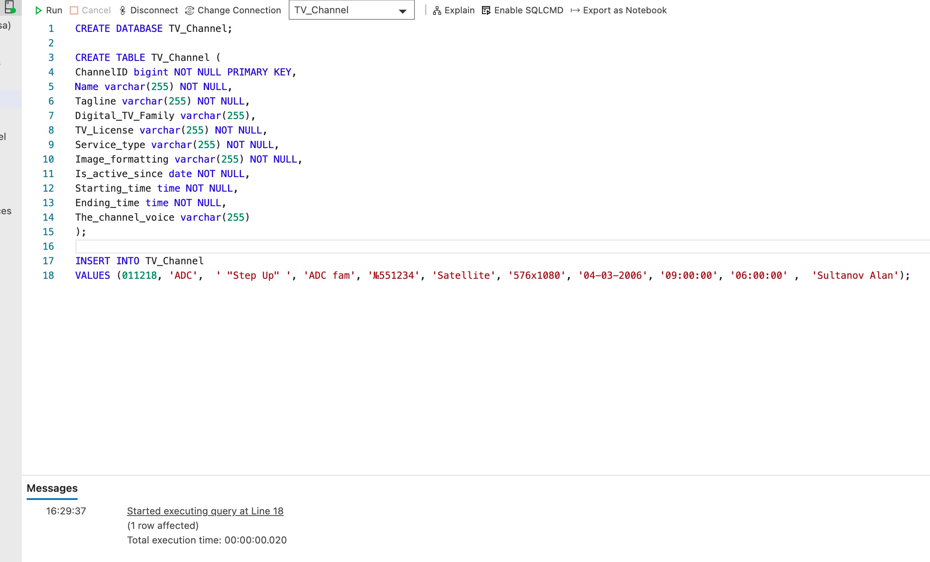

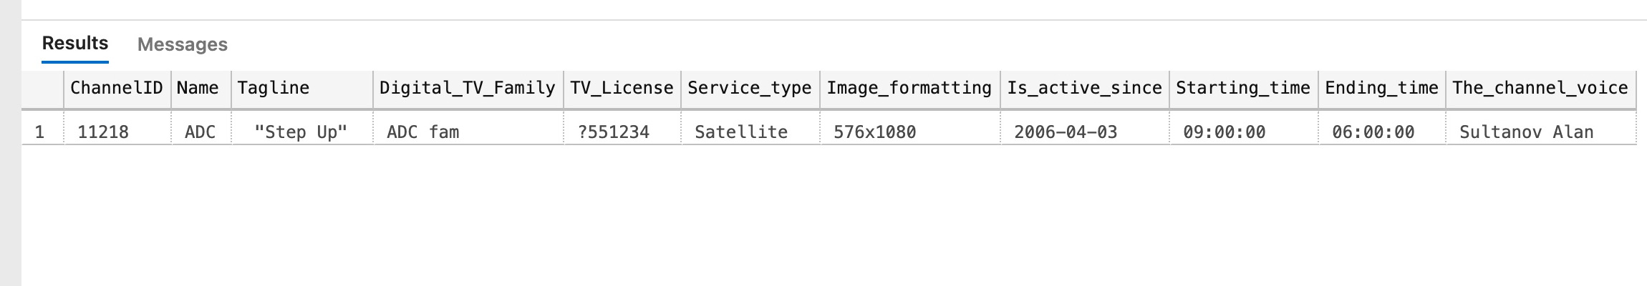

2. ***Creating*** and ***inserting*** ‘Employee’ table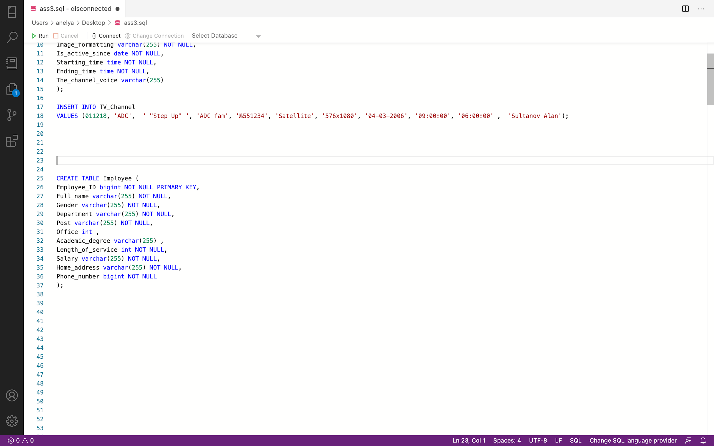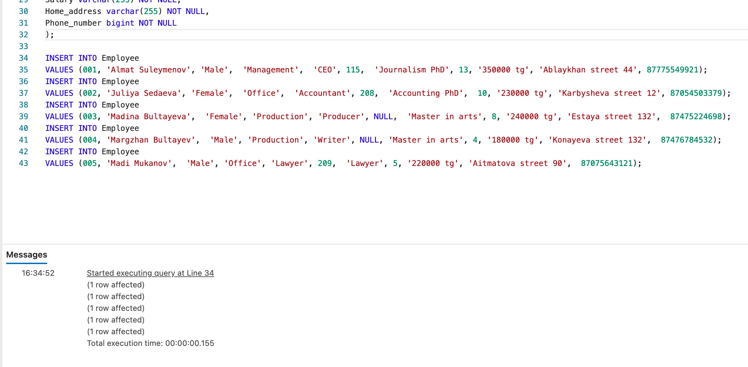

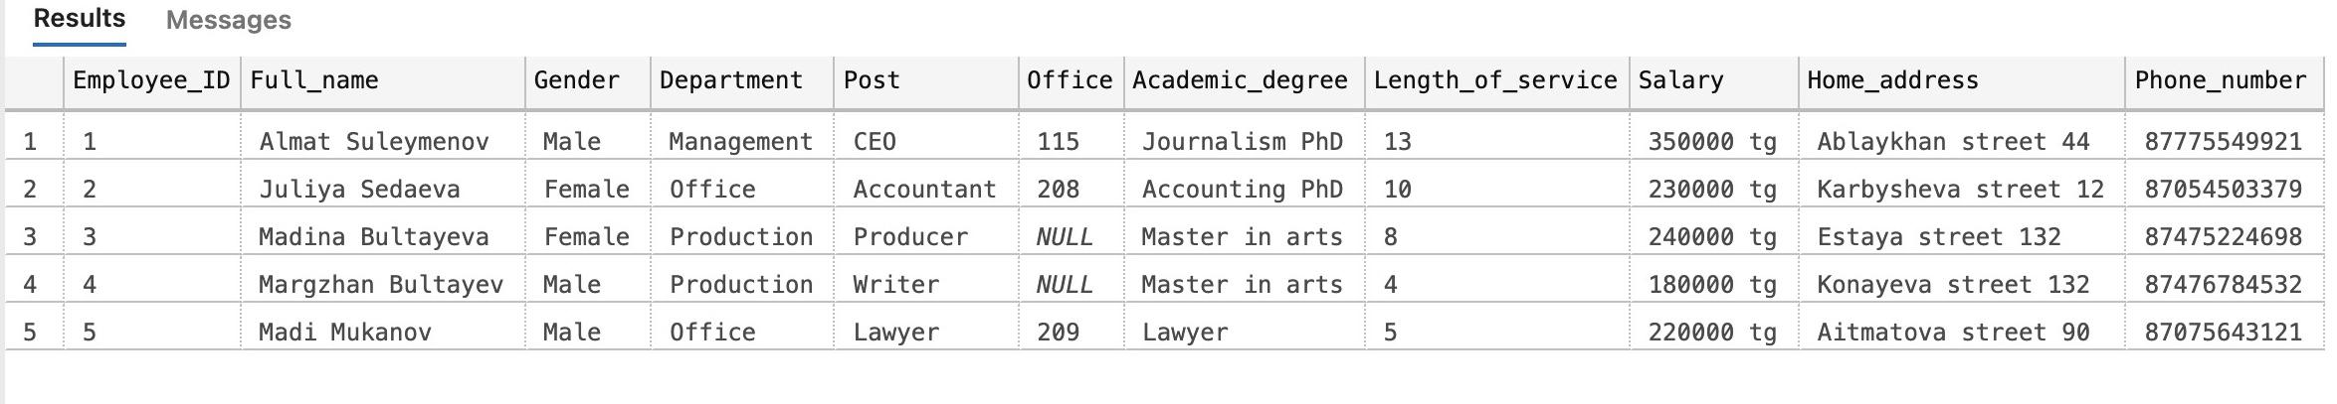

3. ***Creating*** and ***inserting*** ‘TV_License’ table 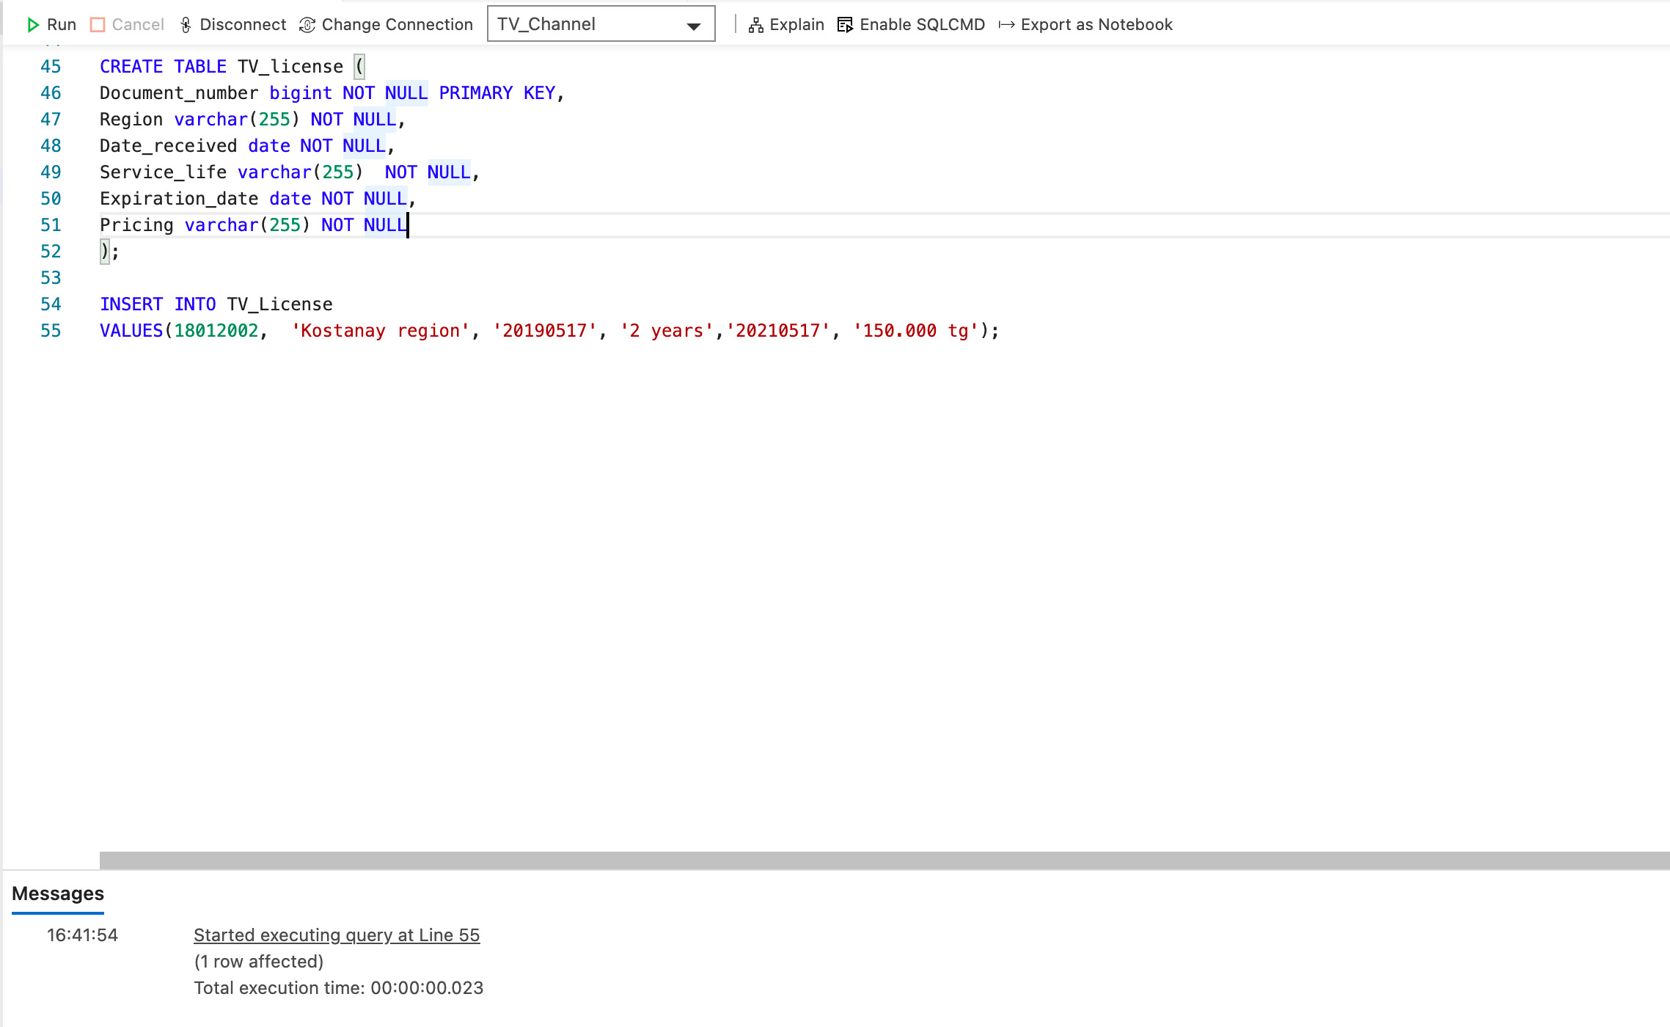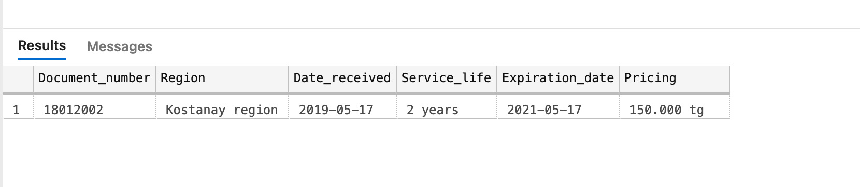

4. ***Creating*** and ***inserting*** ‘Content’ table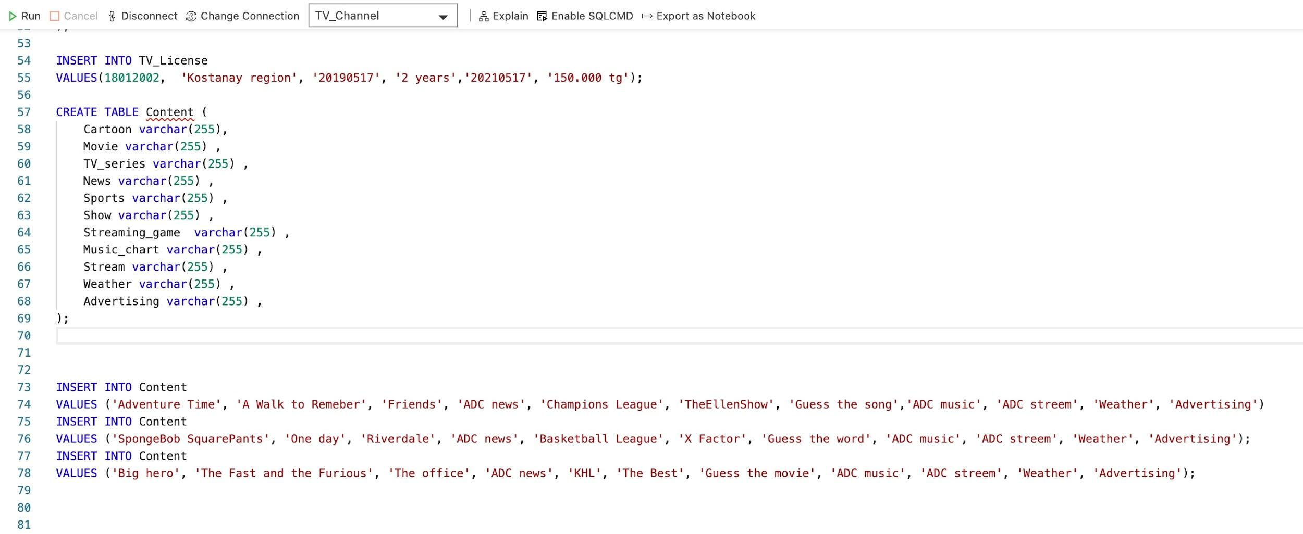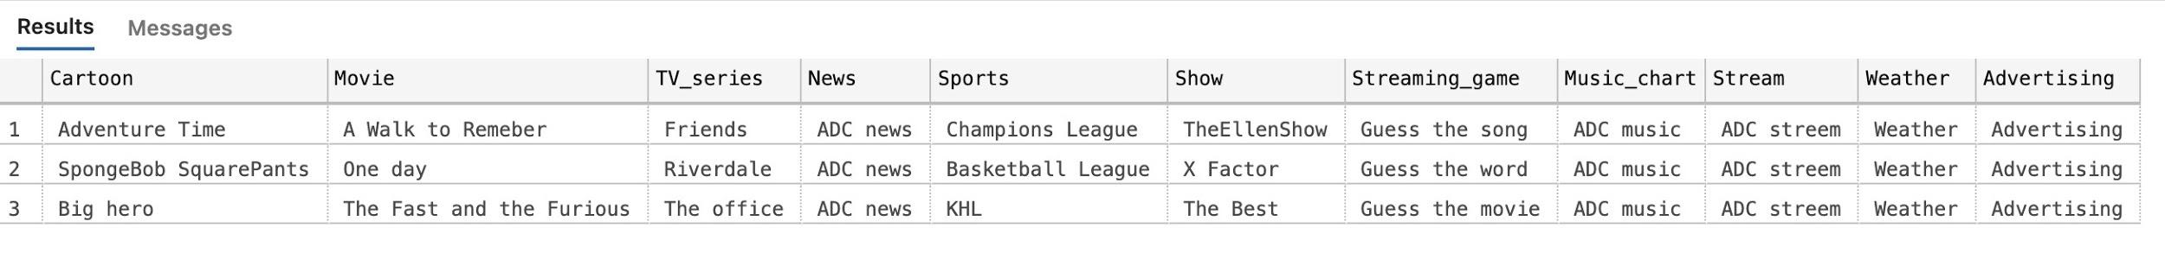

5. ***Creating*** and ***interesting*** ‘Department’ table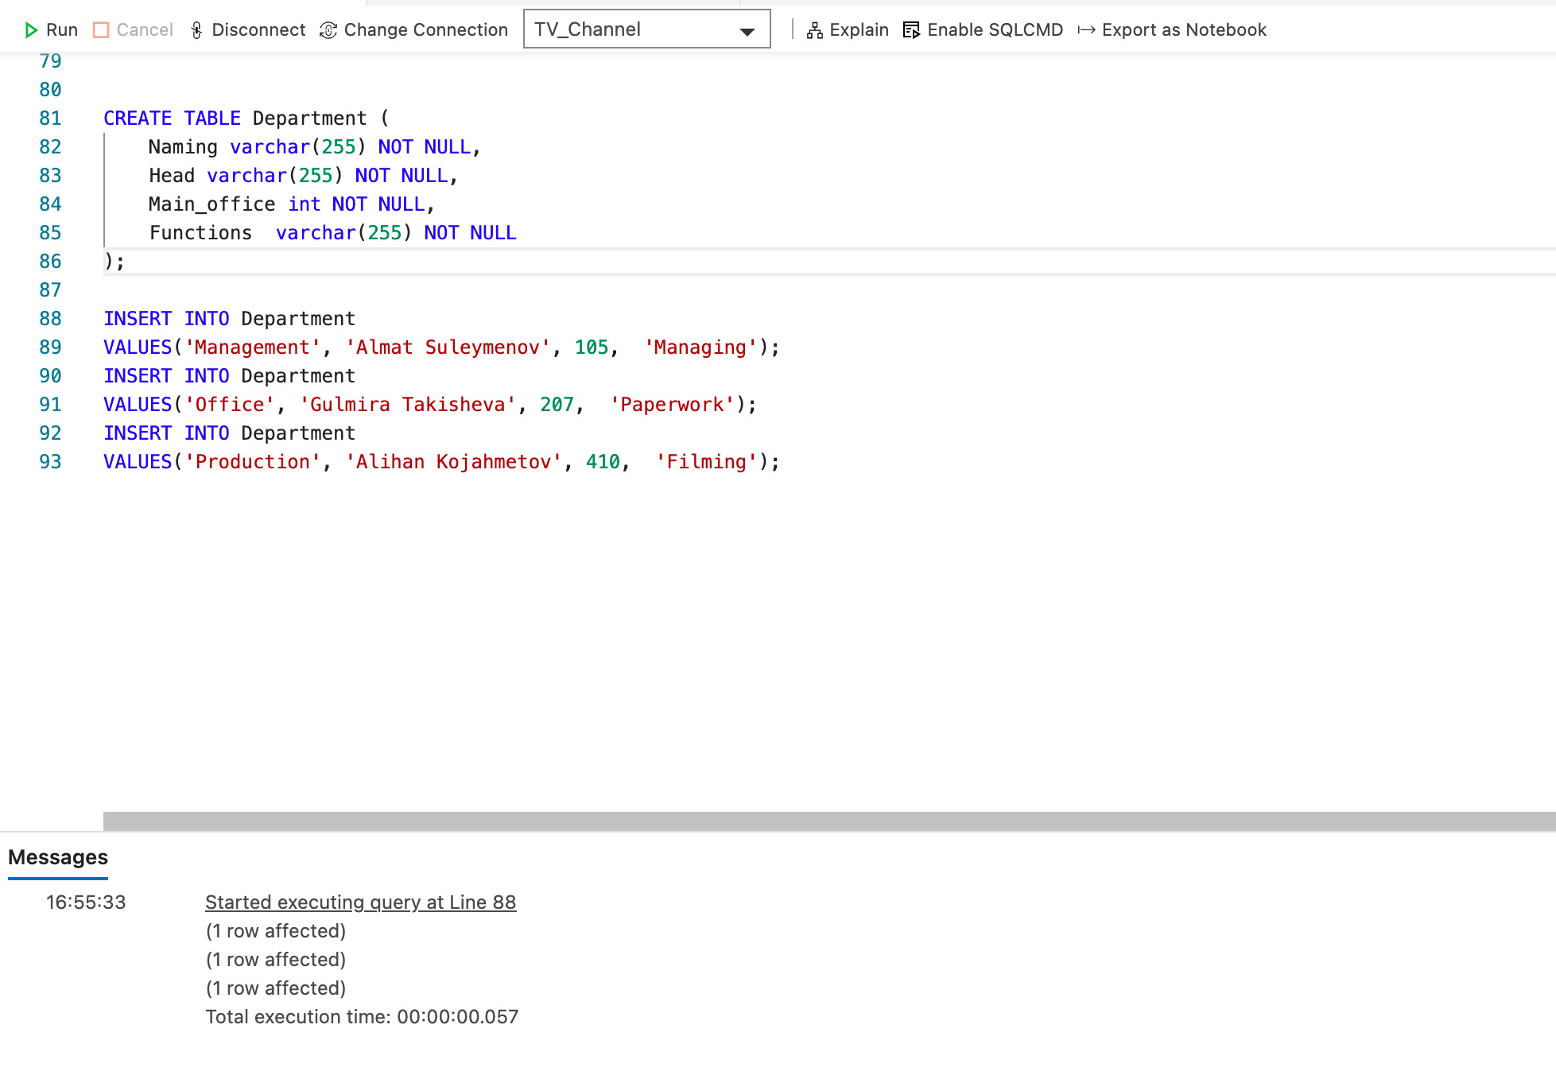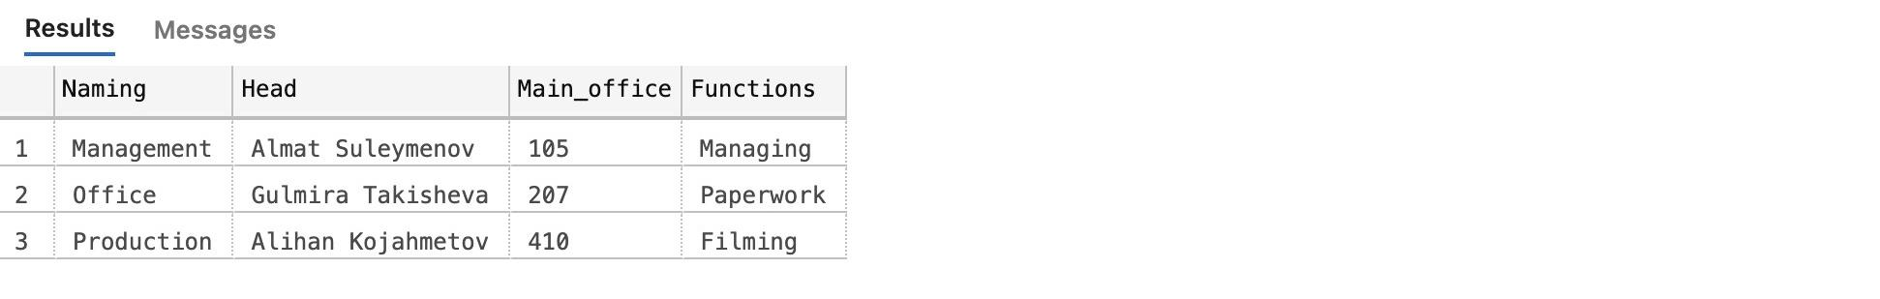

6. ***Creating*** ‘Management’, ‘OfficeDepartment’, and ‘Production’ tables 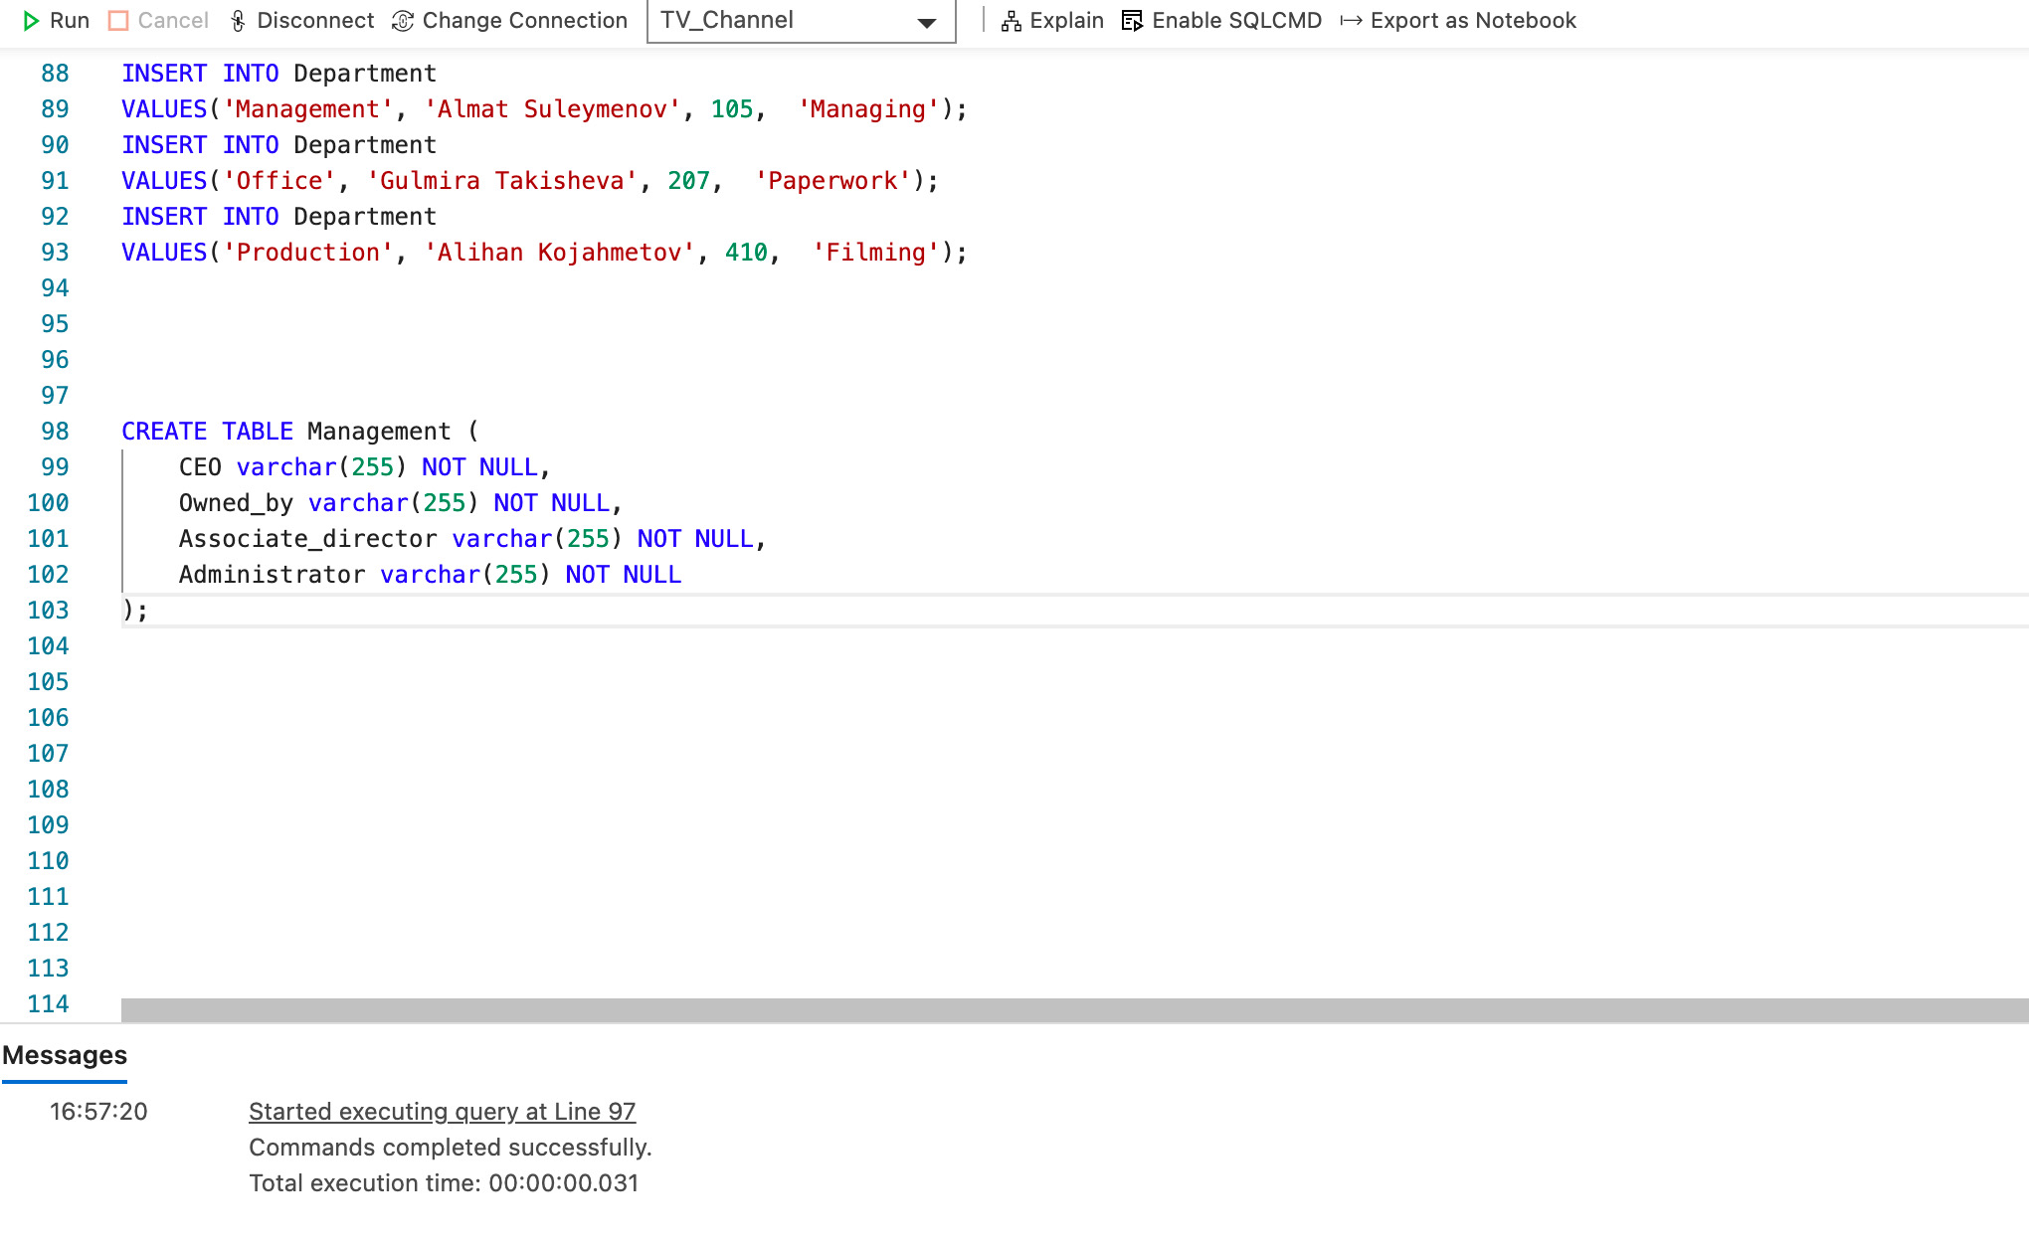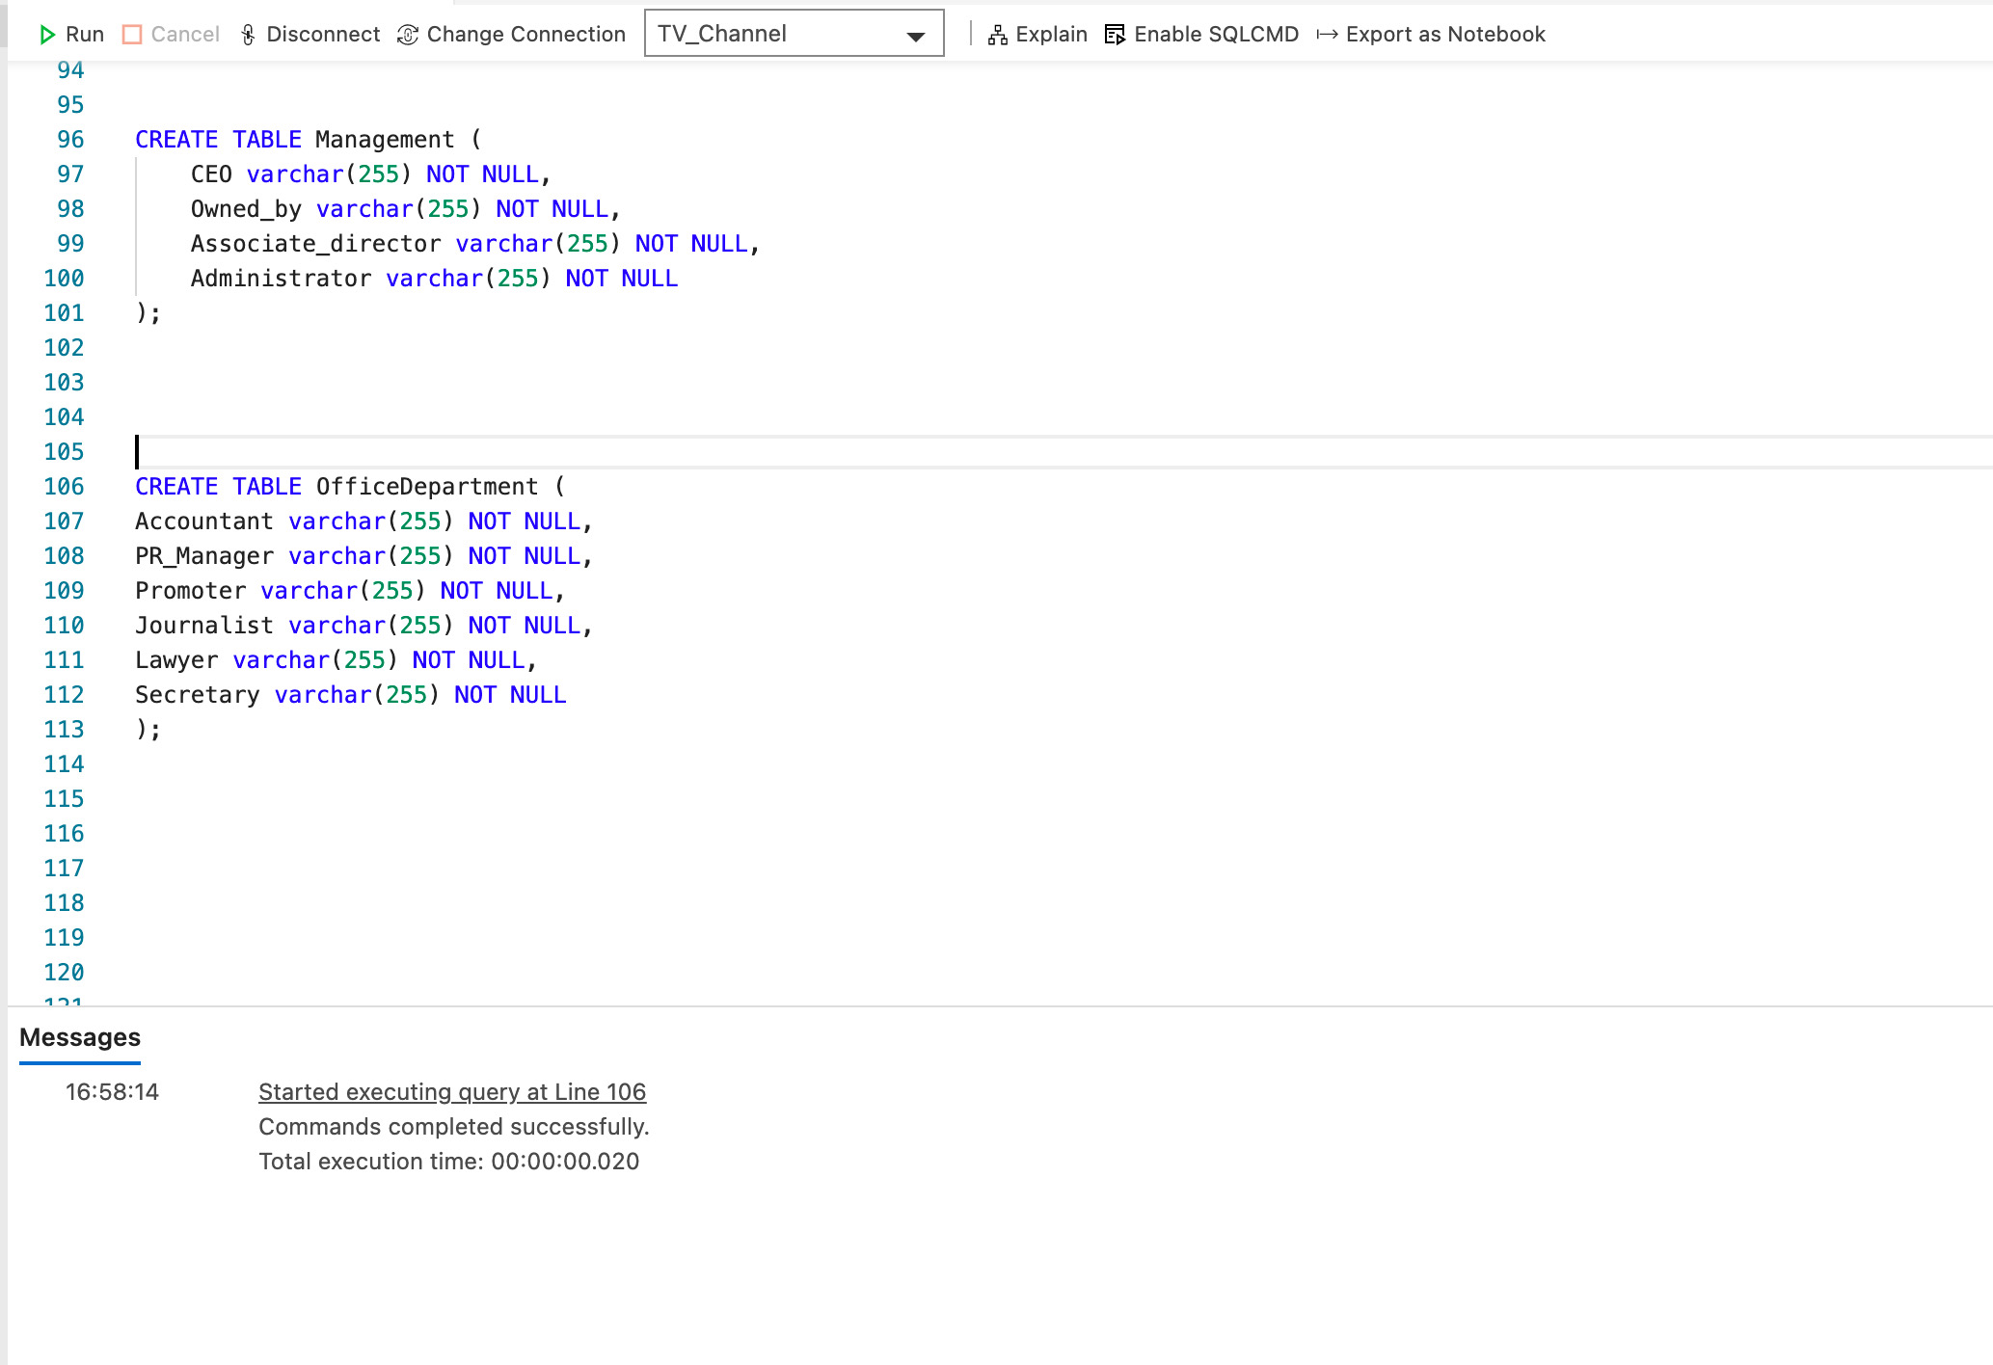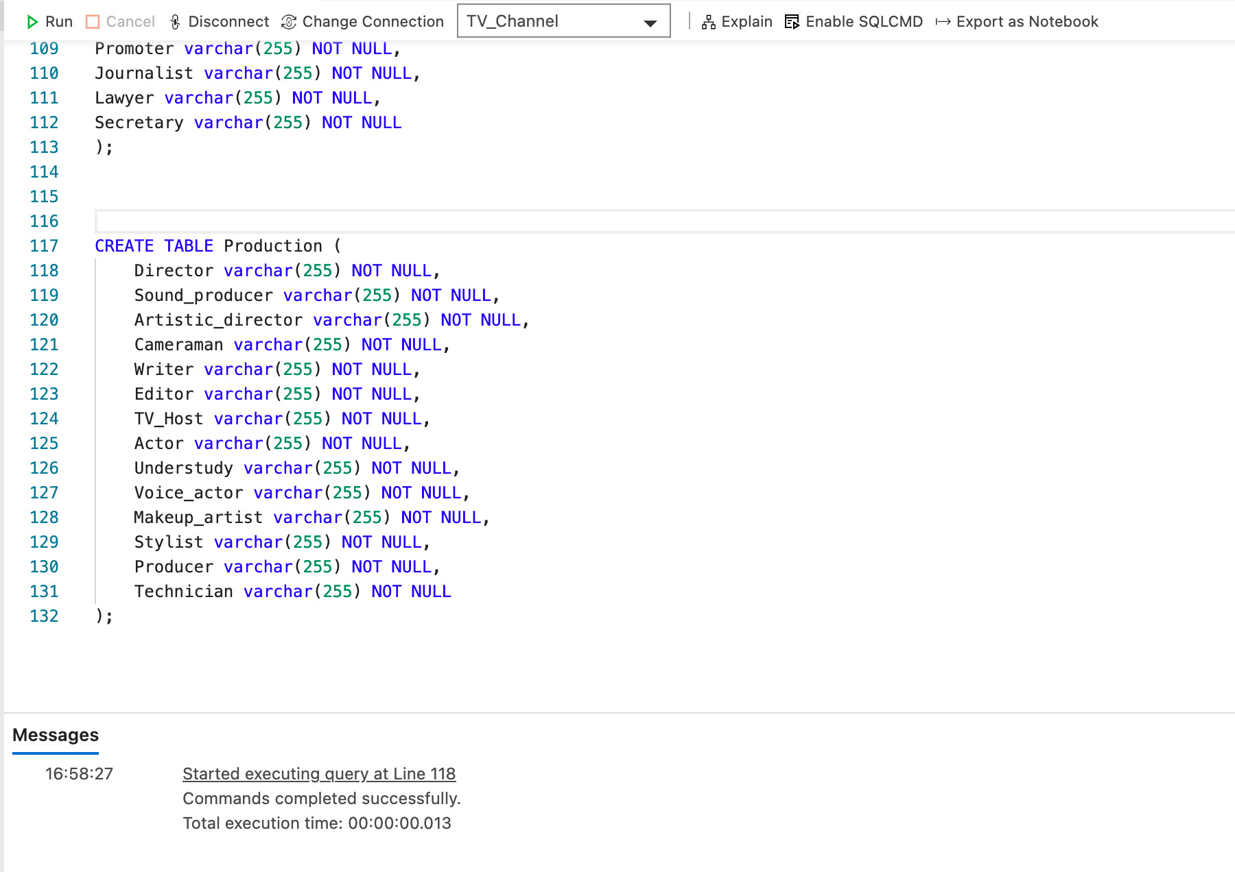

7. ***Creating*** ‘Contacts’, ‘Social media’ tables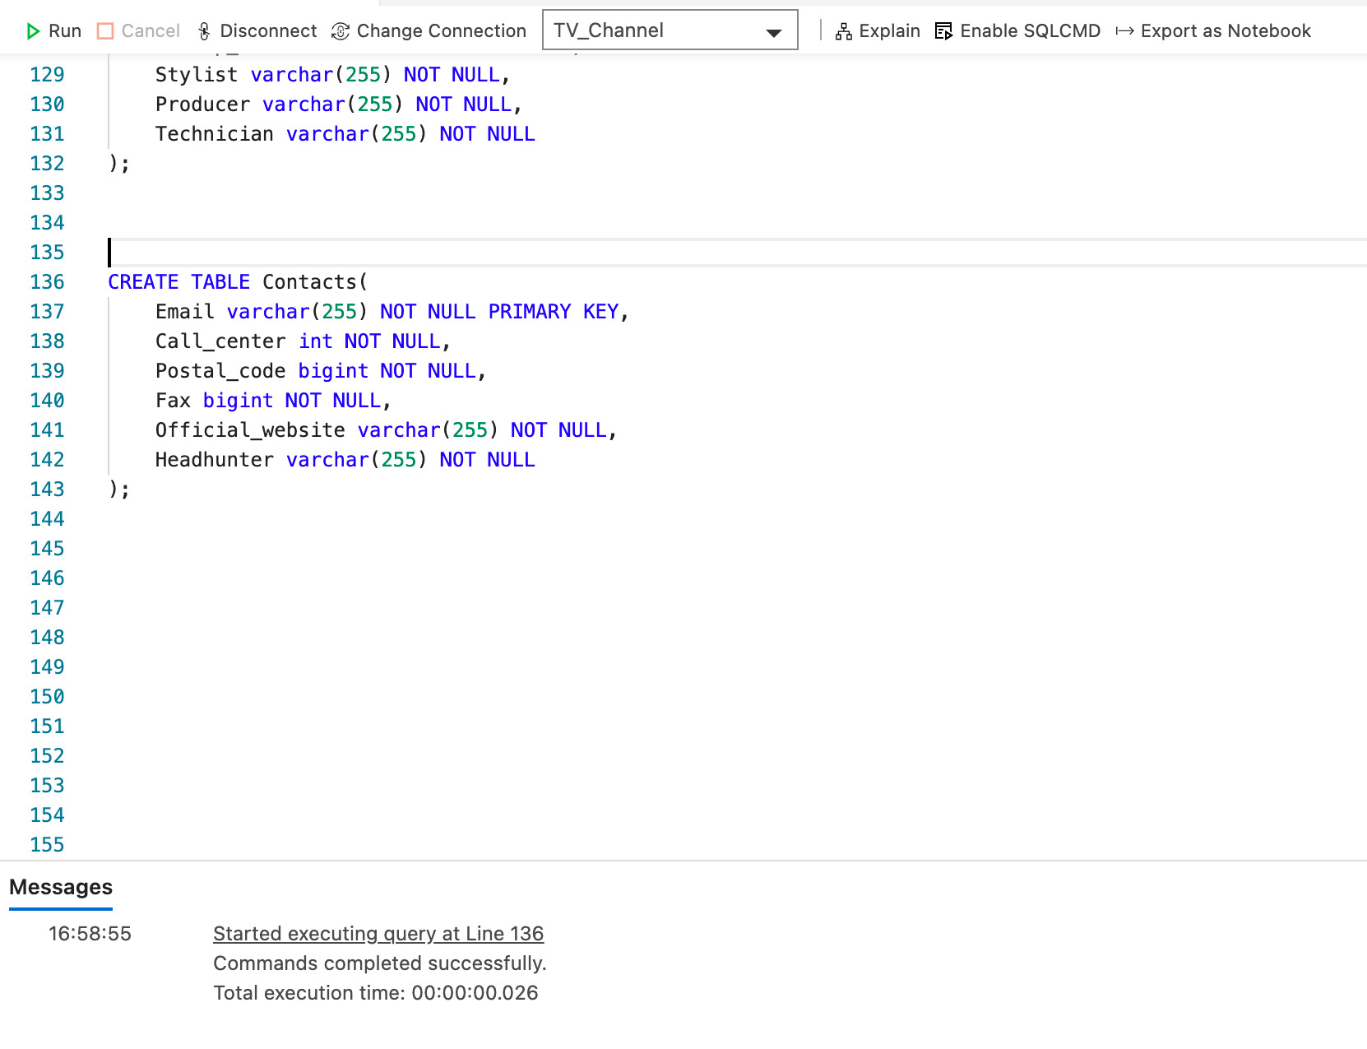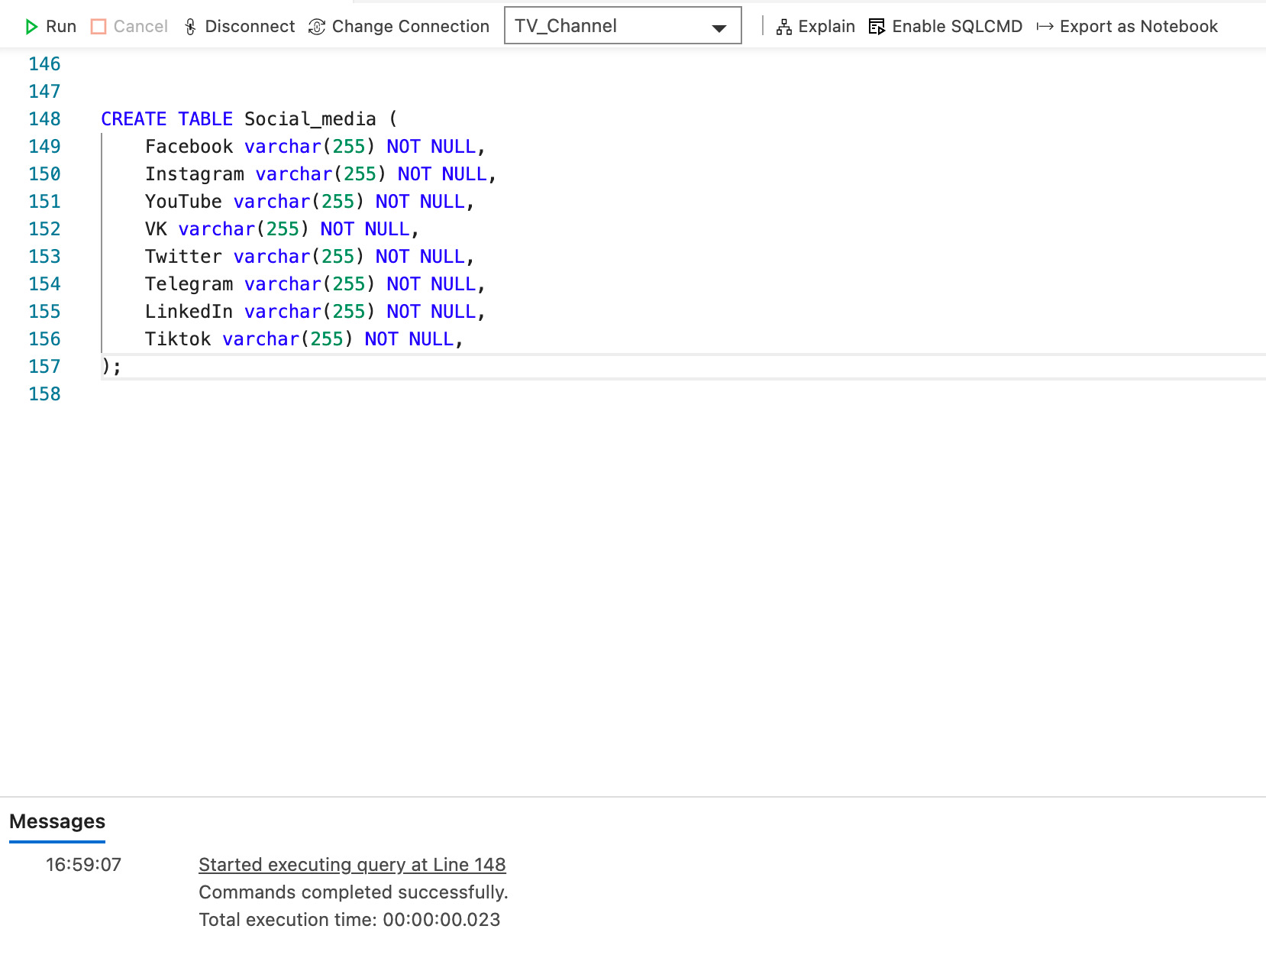

8. ***Creating*** and ***inserting*** ‘Incomes’ table

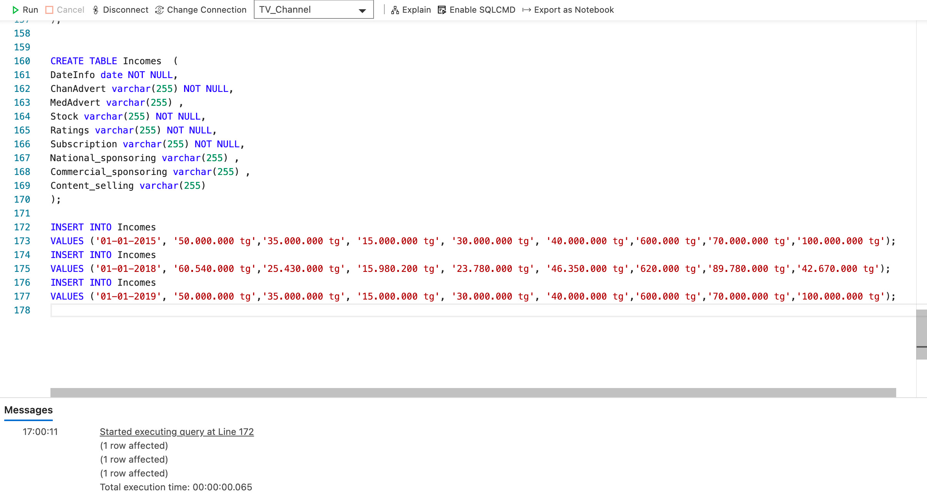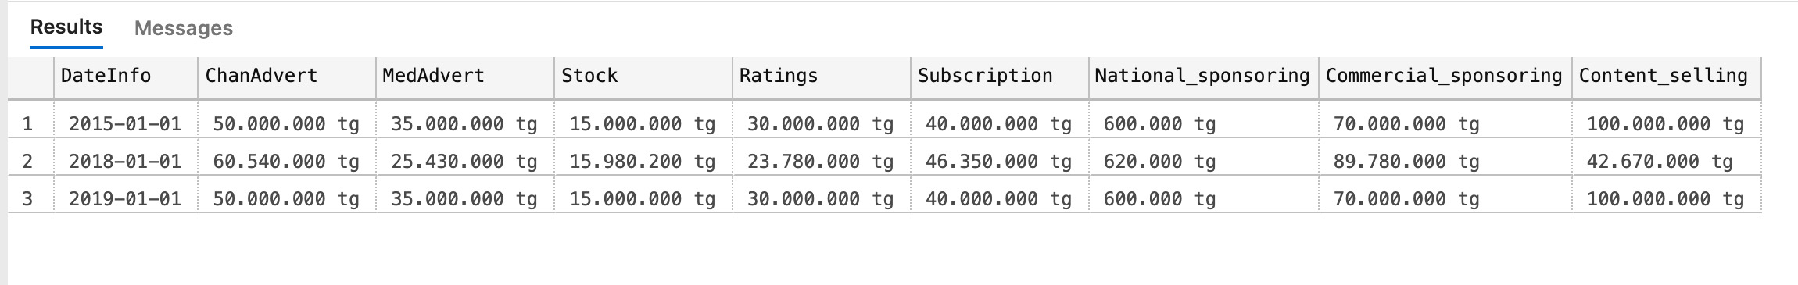

9. ***Creating*** and ***inserting*** ‘Expenses’ table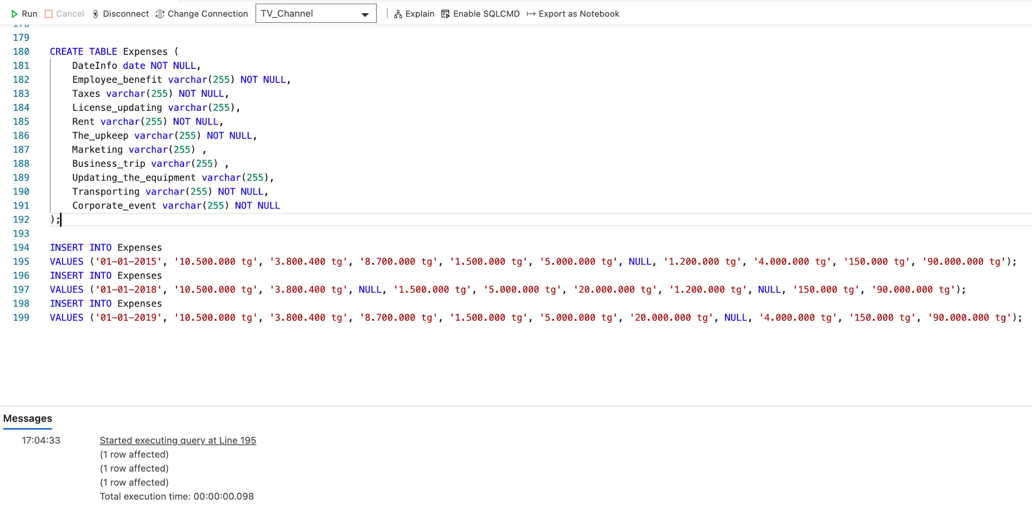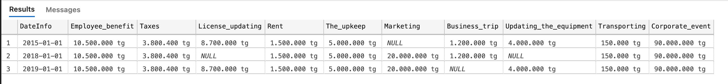

10. ***Creating*** ‘Employee_benefit’, ‘Business_trip’ 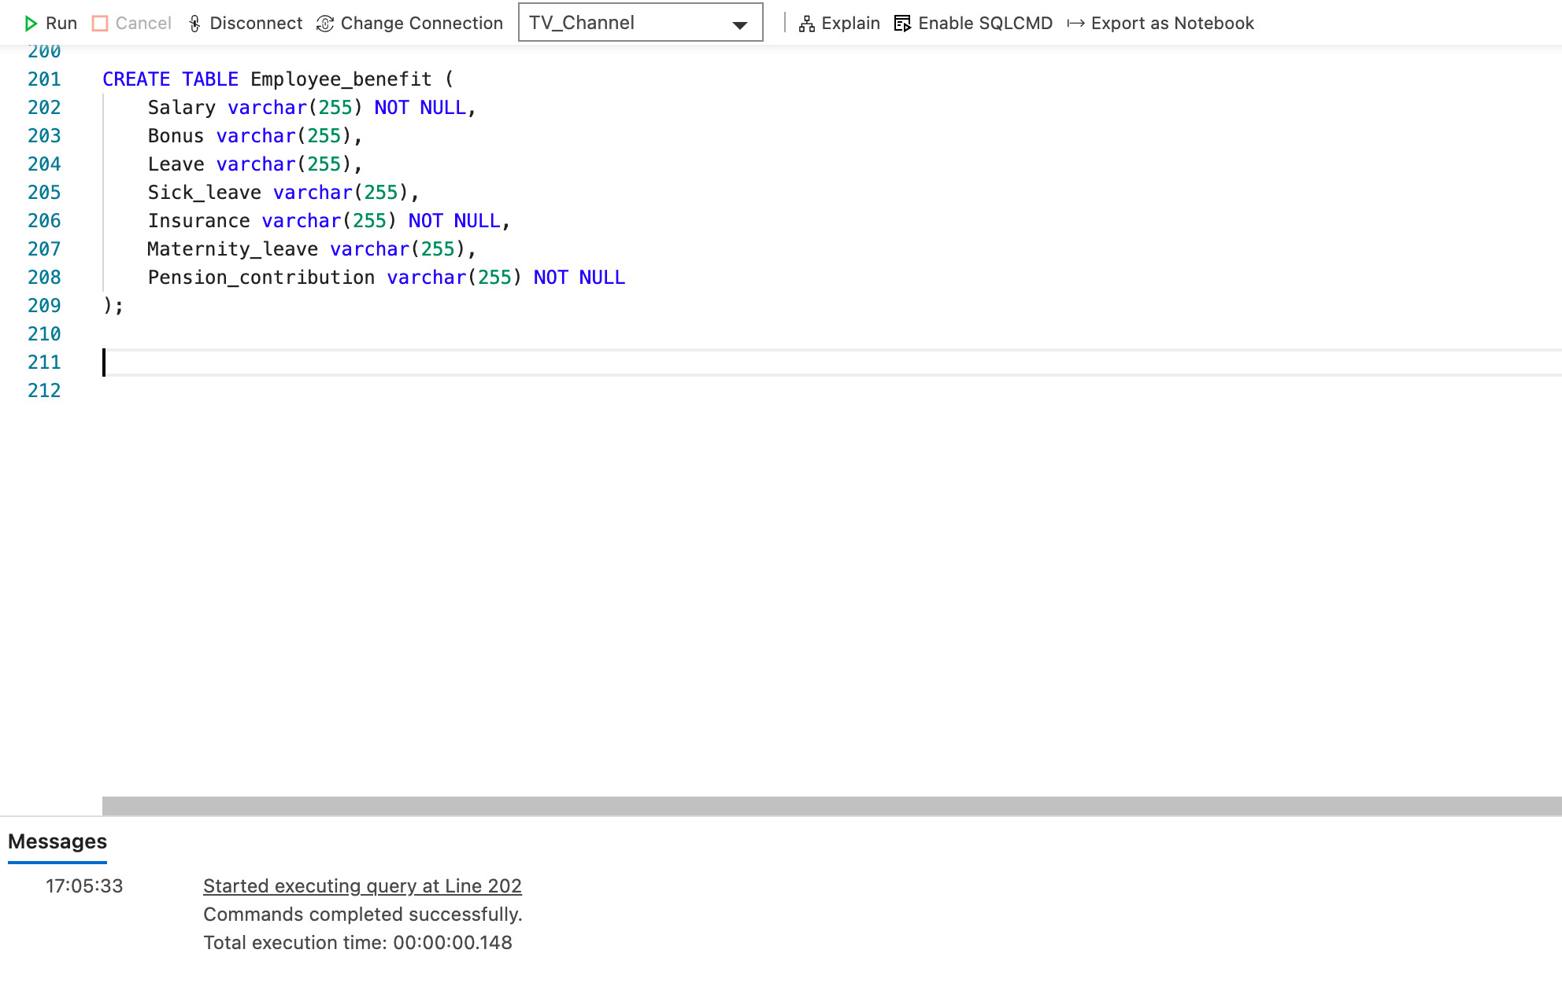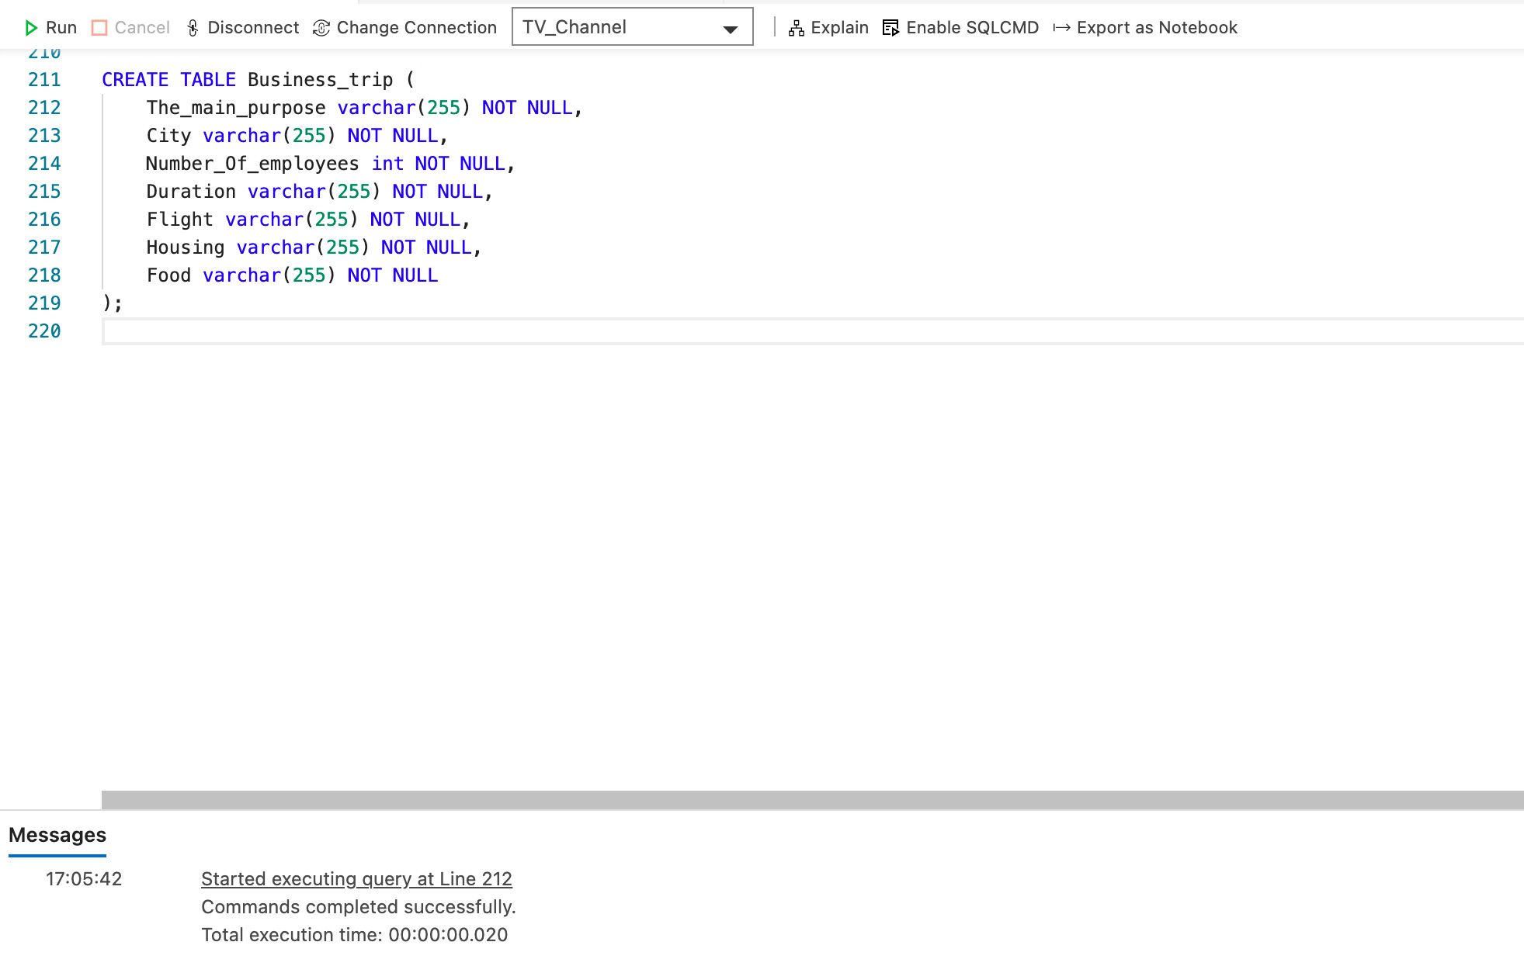

11. ***Updating*** ‘Employee’ table 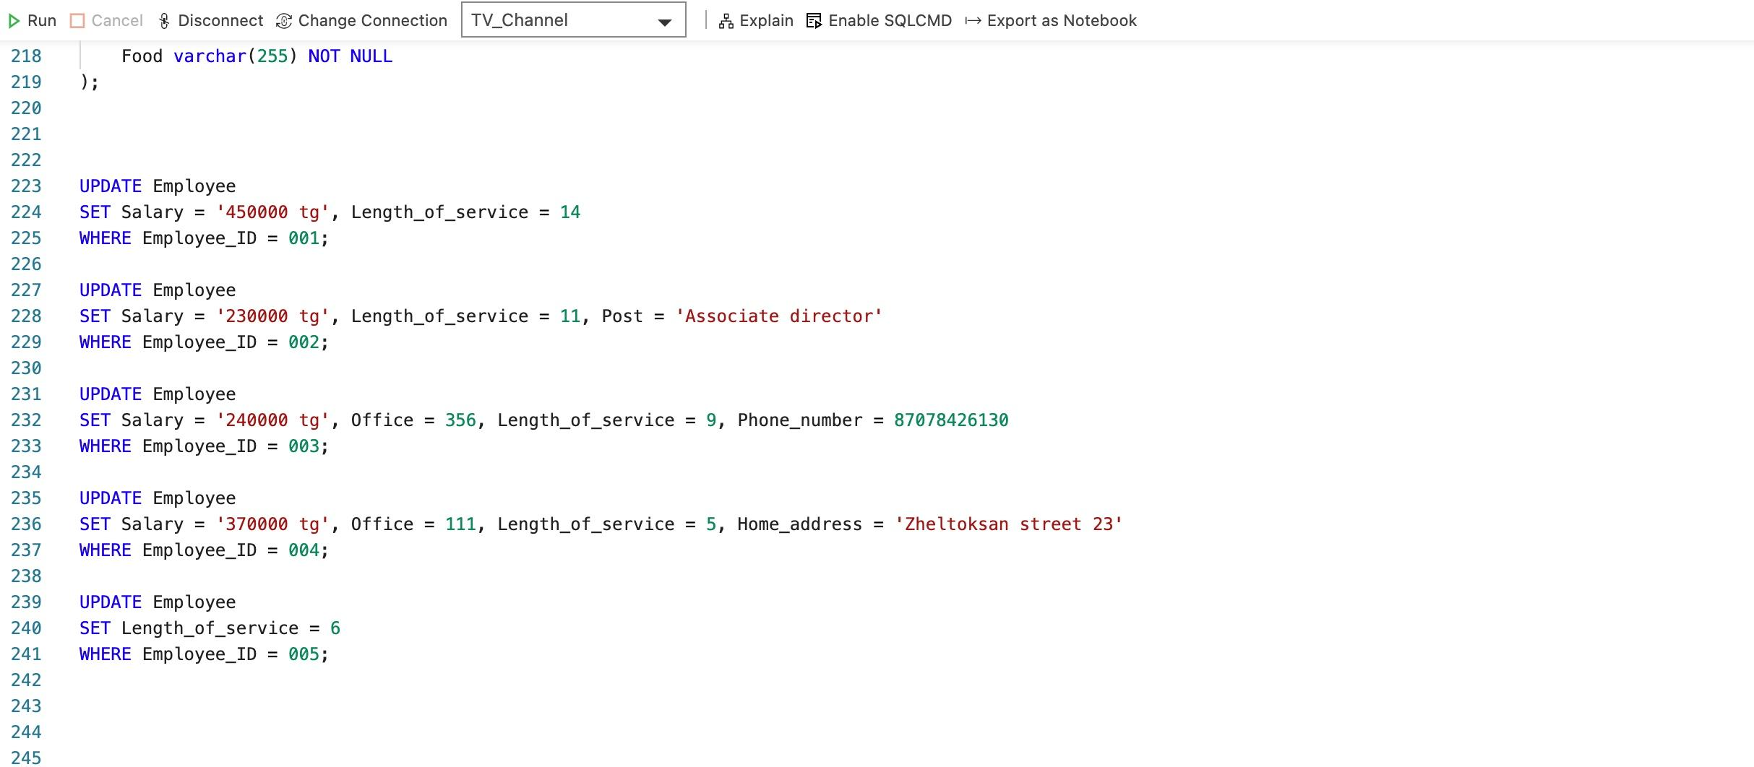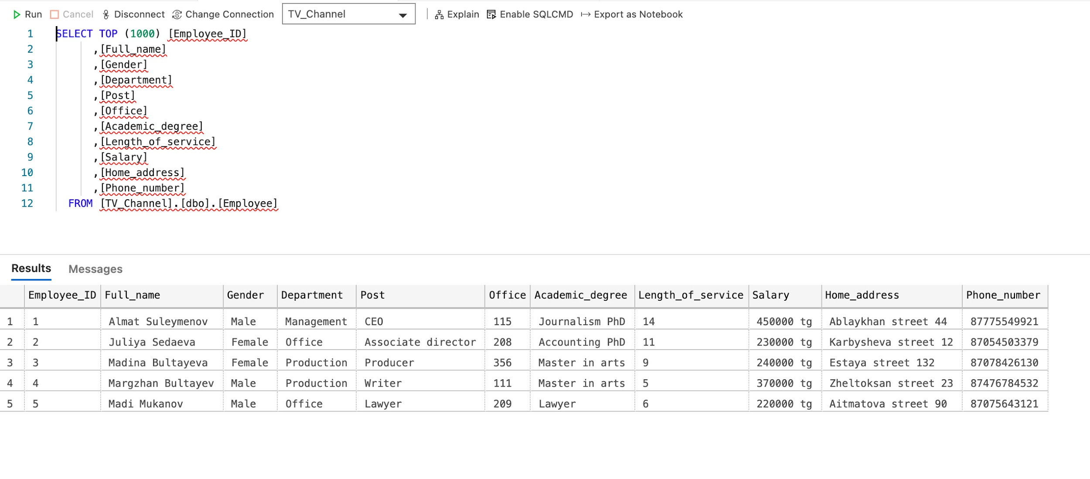

12. ***Updating*** ‘TV_License’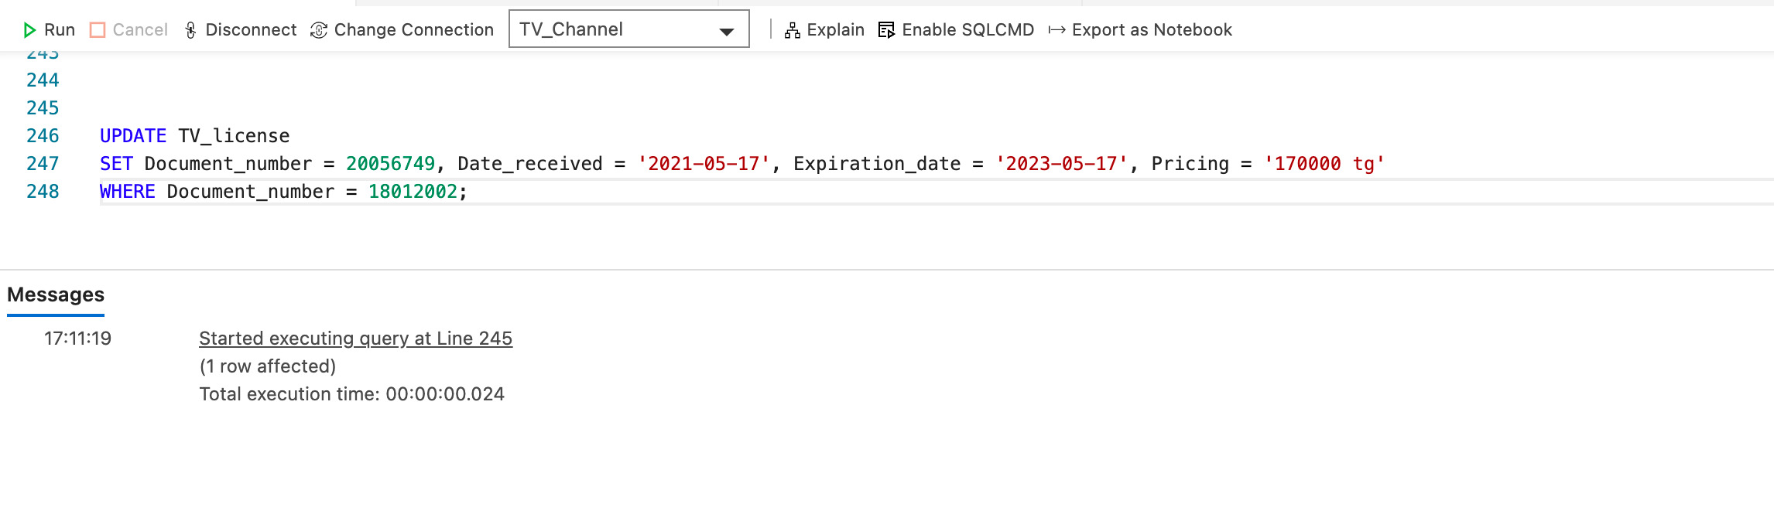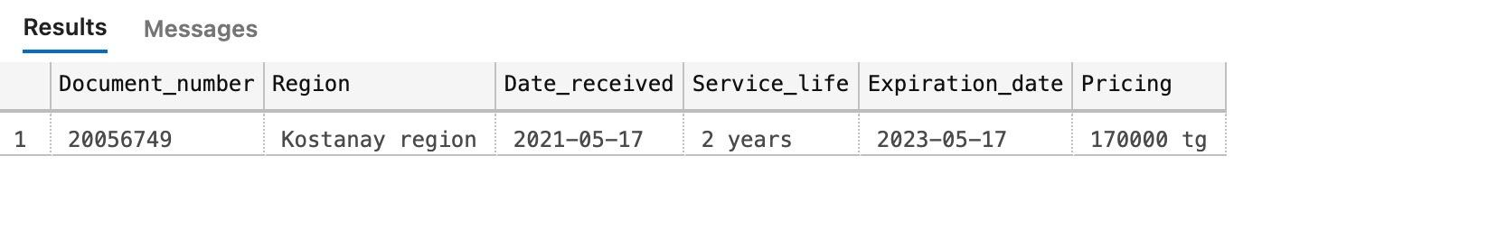

13. ***Deleting*** from ‘Incomes’ table 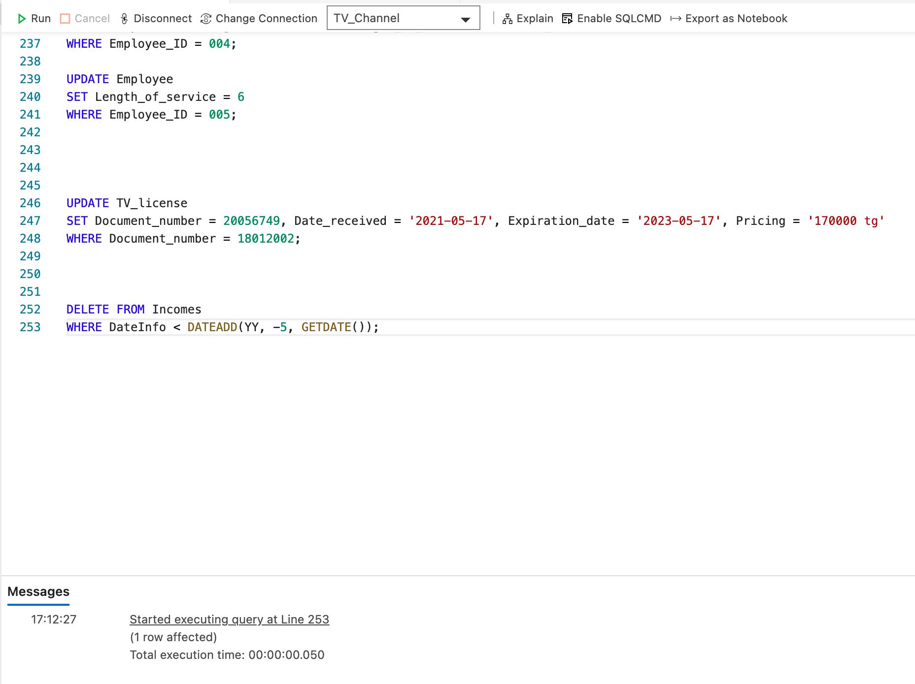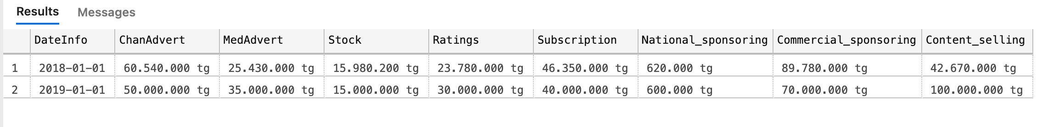

14. ***Deleting*** from ‘Expenses’ table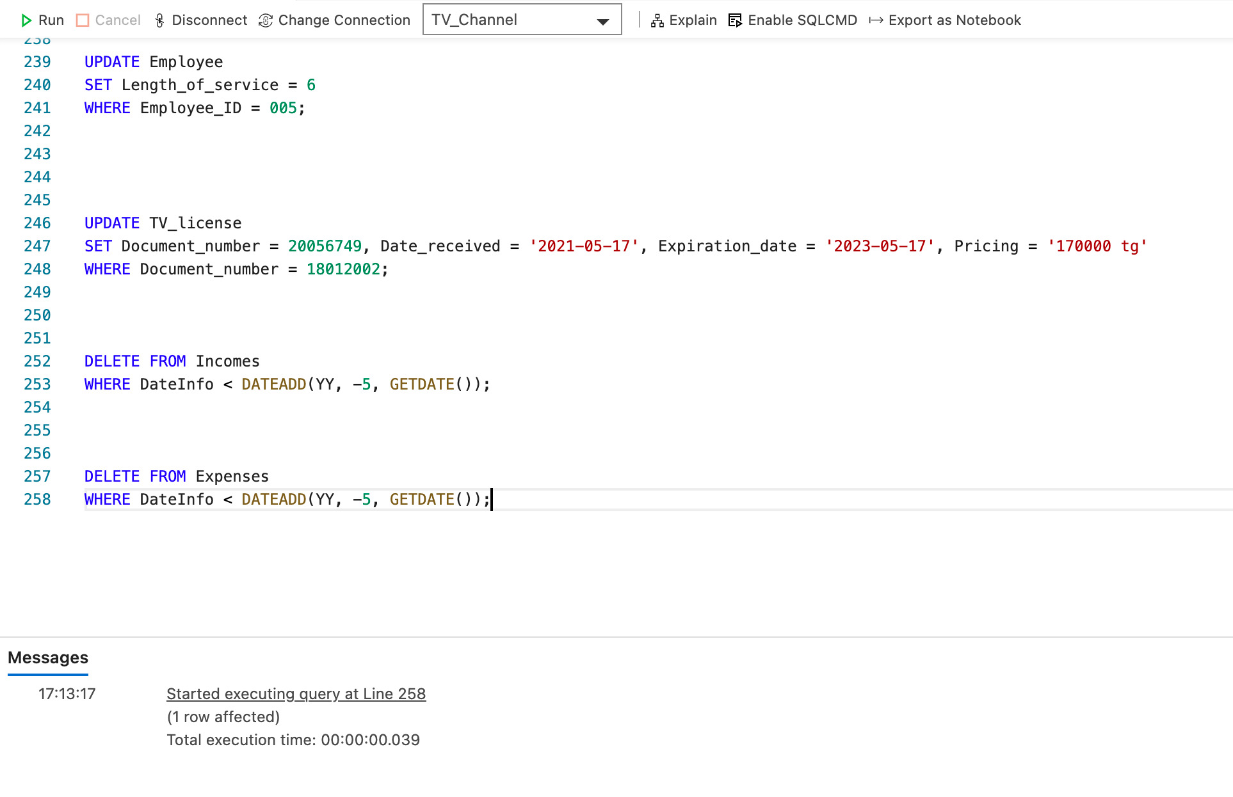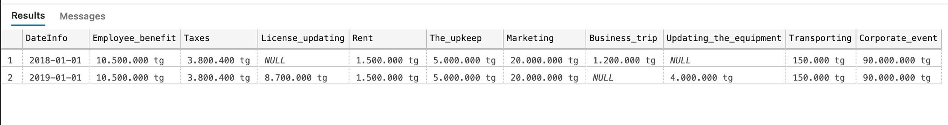

**Also you may see the code in text format:**

CREATE DATABASE TV_Channel;

CREATE TABLE TV_Channel (

ChannelID bigint NOT NULL PRIMARY KEY,

Name varchar(255) NOT NULL,

Tagline varchar(255) NOT NULL,

Digital_TV_Family varchar(255),

TV_License varchar(255) NOT NULL,

Service_type varchar(255) NOT NULL,

Image_formatting varchar(255) NOT NULL,

Is_active_since date NOT NULL,

Starting_time time NOT NULL,

Ending_time time NOT NULL,

The_channel_voice varchar(255)

);

INSERT INTO TV_Channel

VALUES (011218, 'ADC', ' "Step Up" ', 'ADC fam', '№551234', 'Satellite', '576x1080', '04-03-2006', '09:00:00', '06:00:00' , 'Sultanov Alan');

CREATE TABLE Employee (

Employee_ID bigint NOT NULL PRIMARY KEY,

Full_name varchar(255) NOT NULL,

Gender varchar(255) NOT NULL,

Department varchar(255) NOT NULL,

Post varchar(255) NOT NULL,

Office int ,

Academic_degree varchar(255) ,

Length_of_service int NOT NULL,

Salary varchar(255) NOT NULL,

Home_address varchar(255) NOT NULL,

Phone_number bigint NOT NULL

);

INSERT INTO Employee

VALUES (001, 'Almat Suleymenov', 'Male', 'Management', 'CEO', 115, 'Journalism PhD', 13, '350000 tg', 'Ablaykhan street 44', 87775549921);

INSERT INTO Employee

VALUES (002, 'Juliya Sedaeva', 'Female', 'Office', 'Accountant', 208, 'Accounting PhD', 10, '230000 tg', 'Karbysheva street 12', 87054503379);

INSERT INTO Employee

VALUES (003, 'Madina Bultayeva', 'Female', 'Production', 'Producer', NULL, 'Master in arts', 8, '240000 tg', 'Estaya street 132', 87475224698);

INSERT INTO Employee

VALUES (004, 'Margzhan Bultayev', 'Male', 'Production', 'Writer', NULL, 'Master in arts', 4, '180000 tg', 'Konayeva street 132', 87476784532);

INSERT INTO Employee

VALUES (005, 'Madi Mukanov', 'Male', 'Office', 'Lawyer', 209, 'Lawyer', 5, '220000 tg', 'Aitmatova street 90', 87075643121);

CREATE TABLE TV_license (

Document_number bigint NOT NULL PRIMARY KEY,

Region varchar(255) NOT NULL,

Date_received date NOT NULL,

Service_life varchar(255) NOT NULL,

Expiration_date date NOT NULL,

Pricing varchar(255) NOT NULL

);

INSERT INTO TV_License

VALUES(18012002, 'Kostanay region', '20190517', '2 years','20210517', '150.000 tg');

CREATE TABLE Content (

Cartoon varchar(255),

Movie varchar(255) ,

TV_series varchar(255) ,

News varchar(255) ,

Sports varchar(255) ,

Show varchar(255) ,

Streaming_game varchar(255) ,

Music_chart varchar(255) ,

Stream varchar(255) ,

Weather varchar(255) ,

Advertising varchar(255) ,

);

INSERT INTO Content

VALUES ('Adventure Time', 'A Walk to Remeber', 'Friends', 'ADC news', 'Champions League', 'TheEllenShow', 'Guess the song','ADC music', 'ADC streem', 'Weather', 'Advertising')

INSERT INTO Content

VALUES ('SpongeBob SquarePants', 'One day', 'Riverdale', 'ADC news', 'Basketball League', 'X Factor', 'Guess the word', 'ADC music', 'ADC streem', 'Weather', 'Advertising');

INSERT INTO Content

VALUES ('Big hero', 'The Fast and the Furious', 'The office', 'ADC news', 'KHL', 'The Best', 'Guess the movie', 'ADC music', 'ADC streem', 'Weather', 'Advertising');

CREATE TABLE Department (

Naming varchar(255) NOT NULL,

Head varchar(255) NOT NULL,

Main_office int NOT NULL,

Functions varchar(255) NOT NULL

);

INSERT INTO Department

VALUES('Management', 'Almat Suleymenov', 105, 'Managing');

INSERT INTO Department

VALUES('Office', 'Gulmira Takisheva', 207, 'Paperwork');

INSERT INTO Department

VALUES('Production', 'Alihan Kojahmetov', 410, 'Filming');

CREATE TABLE Management (

CEO varchar(255) NOT NULL,

Owned_by varchar(255) NOT NULL,

Associate_director varchar(255) NOT NULL,

Administrator varchar(255) NOT NULL

);

CREATE TABLE OfficeDepartment (

Accountant varchar(255) NOT NULL,

PR_Manager varchar(255) NOT NULL,

Promoter varchar(255) NOT NULL,

Journalist varchar(255) NOT NULL,

Lawyer varchar(255) NOT NULL,

Secretary varchar(255) NOT NULL

);

CREATE TABLE Production (

Director varchar(255) NOT NULL,

Sound_producer varchar(255) NOT NULL,

Artistic_director varchar(255) NOT NULL,

Cameraman varchar(255) NOT NULL,

Writer varchar(255) NOT NULL,

Editor varchar(255) NOT NULL,

TV_Host varchar(255) NOT NULL,

Actor varchar(255) NOT NULL,

Understudy varchar(255) NOT NULL,

Voice_actor varchar(255) NOT NULL,

Makeup_artist varchar(255) NOT NULL,

Stylist varchar(255) NOT NULL,

Producer varchar(255) NOT NULL,

Technician varchar(255) NOT NULL

);

CREATE TABLE Contacts(

Email varchar(255) NOT NULL PRIMARY KEY,

Call_center int NOT NULL,

Postal_code bigint NOT NULL,

Fax bigint NOT NULL,

Official_website varchar(255) NOT NULL,

Headhunter varchar(255) NOT NULL

);

CREATE TABLE Social_media (

Facebook varchar(255) NOT NULL,

Instagram varchar(255) NOT NULL,

YouTube varchar(255) NOT NULL,

VK varchar(255) NOT NULL,

Twitter varchar(255) NOT NULL,

Telegram varchar(255) NOT NULL,

LinkedIn varchar(255) NOT NULL,

Tiktok varchar(255) NOT NULL,

);

CREATE TABLE Incomes (

DateInfo date NOT NULL,

ChanAdvert varchar(255) NOT NULL,

MedAdvert varchar(255) ,

Stock varchar(255) NOT NULL,

Ratings varchar(255) NOT NULL,

Subscription varchar(255) NOT NULL,

National_sponsoring varchar(255) ,

Commercial_sponsoring varchar(255) ,

Content_selling varchar(255)

);

INSERT INTO Incomes

VALUES ('01-01-2015', '50.000.000 tg','35.000.000 tg', '15.000.000 tg', '30.000.000 tg', '40.000.000 tg','600.000 tg','70.000.000 tg','100.000.000 tg');

INSERT INTO Incomes

VALUES ('01-01-2018', '60.540.000 tg','25.430.000 tg', '15.980.200 tg', '23.780.000 tg', '46.350.000 tg','620.000 tg','89.780.000 tg','42.670.000 tg');

INSERT INTO Incomes

VALUES ('01-01-2019', '50.000.000 tg','35.000.000 tg', '15.000.000 tg', '30.000.000 tg', '40.000.000 tg','600.000 tg','70.000.000 tg','100.000.000 tg');

CREATE TABLE Expenses (

DateInfo date NOT NULL,

Employee_benefit varchar(255) NOT NULL,

Taxes varchar(255) NOT NULL,

License_updating varchar(255),

Rent varchar(255) NOT NULL,

The_upkeep varchar(255) NOT NULL,

Marketing varchar(255) ,

Business_trip varchar(255) ,

Updating_the_equipment varchar(255),

Transporting varchar(255) NOT NULL,

Corporate_event varchar(255) NOT NULL

);

INSERT INTO Expenses

VALUES ('01-01-2015', '10.500.000 tg', '3.800.400 tg', '8.700.000 tg', '1.500.000 tg', '5.000.000 tg', NULL, '1.200.000 tg', '4.000.000 tg', '150.000 tg', '90.000.000 tg');

INSERT INTO Expenses

VALUES ('01-01-2018', '10.500.000 tg', '3.800.400 tg', NULL, '1.500.000 tg', '5.000.000 tg', '20.000.000 tg', '1.200.000 tg', NULL, '150.000 tg', '90.000.000 tg');

INSERT INTO Expenses

VALUES ('01-01-2019', '10.500.000 tg', '3.800.400 tg', '8.700.000 tg', '1.500.000 tg', '5.000.000 tg', '20.000.000 tg', NULL, '4.000.000 tg', '150.000 tg', '90.000.000 tg');

CREATE TABLE Employee_benefit (

Salary varchar(255) NOT NULL,

Bonus varchar(255),

Leave varchar(255),

Sick_leave varchar(255),

Insurance varchar(255) NOT NULL,

Maternity_leave varchar(255),

Pension_contribution varchar(255) NOT NULL

);

CREATE TABLE Business_trip (

The_main_purpose varchar(255) NOT NULL,

City varchar(255) NOT NULL,

Number_Of_employees int NOT NULL,

Duration varchar(255) NOT NULL,

Flight varchar(255) NOT NULL,

Housing varchar(255) NOT NULL,

Food varchar(255) NOT NULL

);

UPDATE Employee

SET Salary = '450000 tg', Length_of_service = 14

WHERE Employee_ID = 001;

UPDATE Employee

SET Salary = '230000 tg', Length_of_service = 11, Post = 'Associate director'

WHERE Employee_ID = 002;

UPDATE Employee

SET Salary = '240000 tg', Office = 356, Length_of_service = 9, Phone_number = 87078426130

WHERE Employee_ID = 003;

UPDATE Employee

SET Salary = '370000 tg', Office = 111, Length_of_service = 5, Home_address = 'Zheltoksan street 23'

WHERE Employee_ID = 004;

UPDATE Employee

SET Length_of_service = 6

WHERE Employee_ID = 005;

UPDATE TV_license

SET Document_number = 20056749, Date_received = '2021-05-17', Expiration_date = '2023-05-17', Pricing = '170000 tg'

WHERE Document_number = 18012002;

DELETE FROM Incomes

WHERE DateInfo < DATEADD(YY, -5, GETDATE());

DELETE FROM Expenses

WHERE DateInfo < DATEADD(YY, -5, GETDATE());